
www.robotwarriors.info
www.robotwarriors.info
www.robotwarriors.info
www.robotwarriors.info
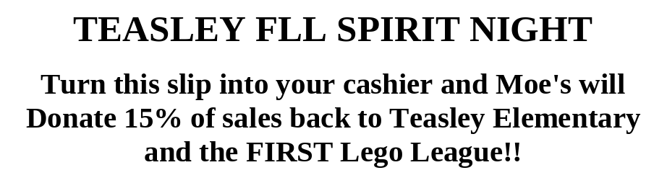
TEASLEY FLL SPIRIT NIGHT

Turn this slip into your cashier and Moe's will
Donate 15% of sales back to Teasley Elementary
and the FIRST Lego League!!

TEASLEY FLL SPIRIT NIGHT

Turn this slip into your cashier and Moe's will
Donate 15% of sales back to Teasley Elementary
and the FIRST Lego League!!

TEASLEY FLL SPIRIT NIGHT

Turn this slip into your cashier and Moe's will
Donate 15% of sales back to Teasley Elementary
and the FIRST Lego League!!

Redeemable only at:

Smyrna Market Village
2840 Atlanta Road SE
Smyrna, GA 30080
(770) 319-6880

Redeemable only at:

Smyrna Market Village
2840 Atlanta Road SE
Smyrna, GA 30080
(770) 319-6880

Redeemable only at:

Smyrna Market Village
2840 Atlanta Road SE
Smyrna, GA 30080
(770) 319-6880

Redeemable only at:

Smyrna Market Village
2840 Atlanta Road SE
Smyrna, GA 30080
(770) 319-6880

